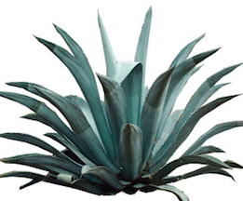 Antigua Barbuda Horticultural Society
We are now open Monday, Wednesday, Friday and Saturdays

The Agave Garden is developing to display the flowers; plants, medicinal herbs, trees and landscape of Antigua with a West Indian style Agave Centre. The Garden will offer a serene escape from busy lives and an opportunity to become more aware of the natural beauty of Antigua.

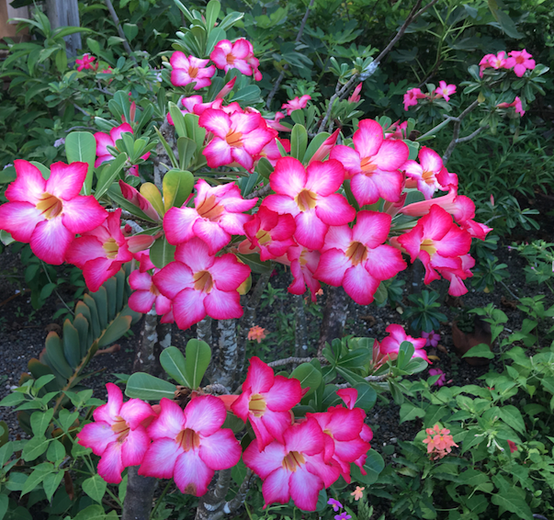

Agave gardens is now open Monday/Wednesday/Friday and Saturdays at Friars Hill Road, St. John’s
Stop by and relax in our beautiful developing gardens, have a cool drink or enjoy our botanical library, and gift shop.
See whats in the green house!
www.antiguahorticulture.com
https://www.facebook.com/AntiguaHorticultureSociety
Or telephone 268 725 5507 Please join us!

